DEVOPS TASK- 2

**Step 1:Installation of Docker:**

**CODE :**

sudo apt install docker.io Docker –version sudo systemctl start docker sudo systemctl enable docker

sudo systemctl status docker

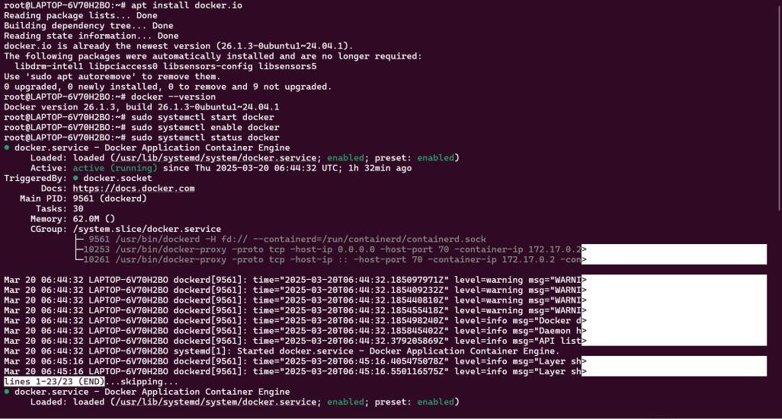

**Step 2:Fork**

Fork a copy of a GitHub repo which contains the necessary files which will result in the clone of that repo in our own repository

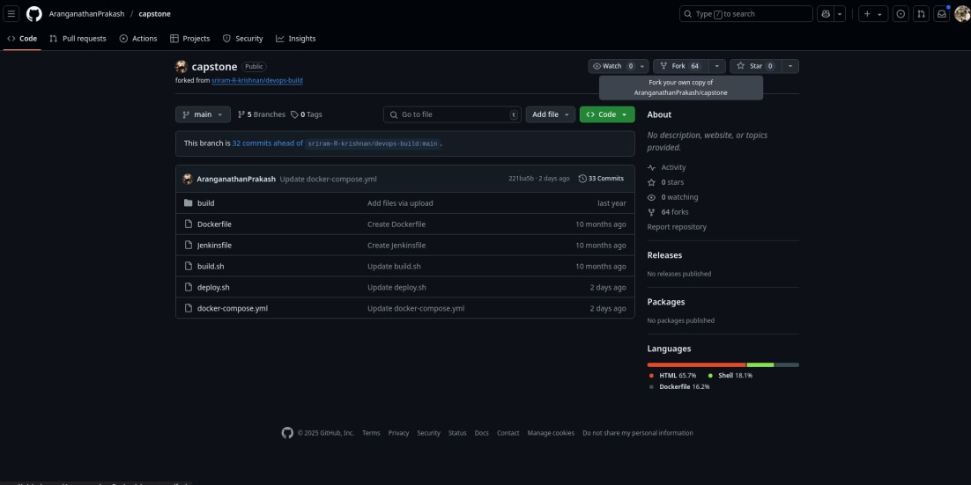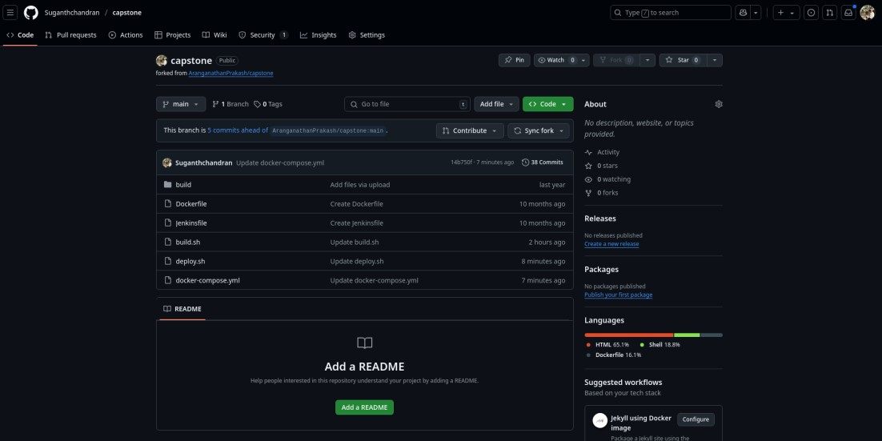

1. Then change the token and repo name of the docker Hub in the deploy.sh file which is in our repository.

**SCREENSHOT :**

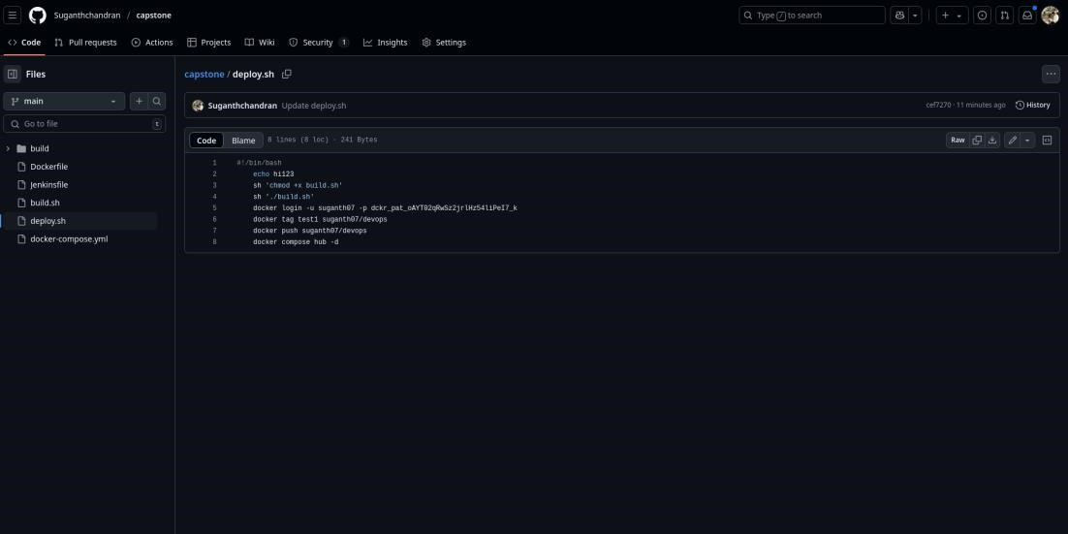

1. Then copy the GitHub link of the repository and go to Jenkins.

**SCREENSHOT:**

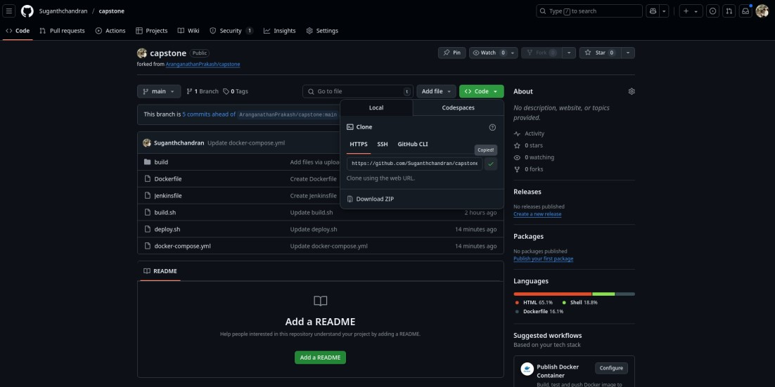

1. In Jenkins, create a new item (Job) with a type pipeline and add the copied GitHub url to it with the correct branch and Jenkinsfile.

**SCREENSHOT:**

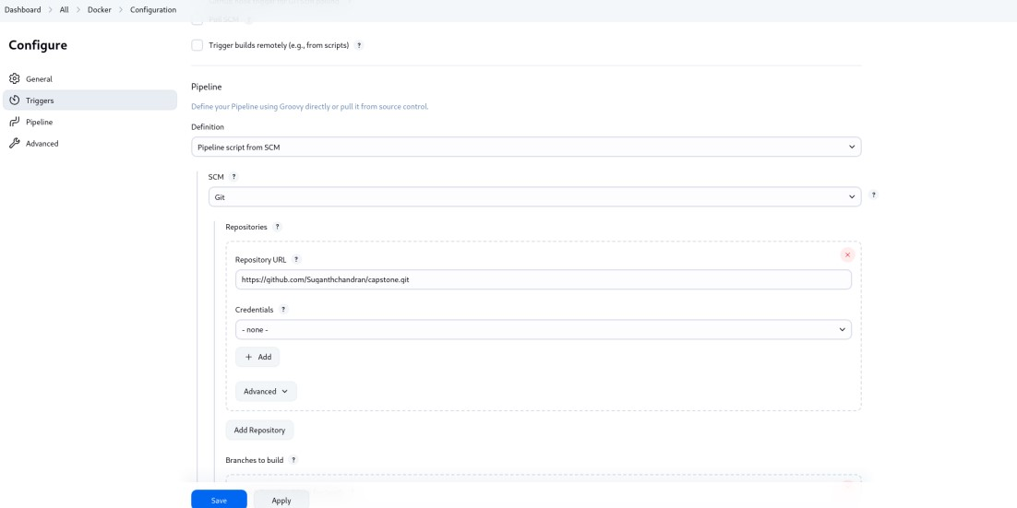

1. After Creating the job, build it and it will give the console output and the docker image will be created.

**SCREENSHOT:**

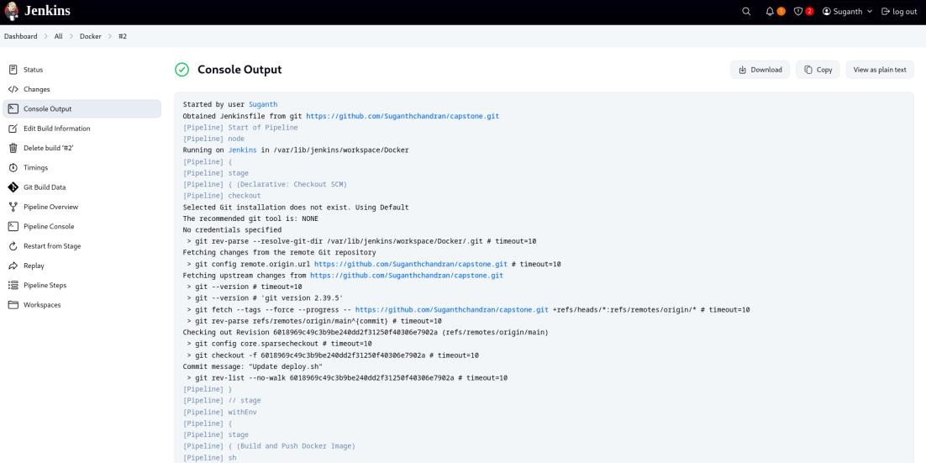

1. Now Built this docker image in the terminal with desired port number to it.

**CODE:**

docker images

docker build –itd –p 70:80 test1

**SCREENSHOT:**

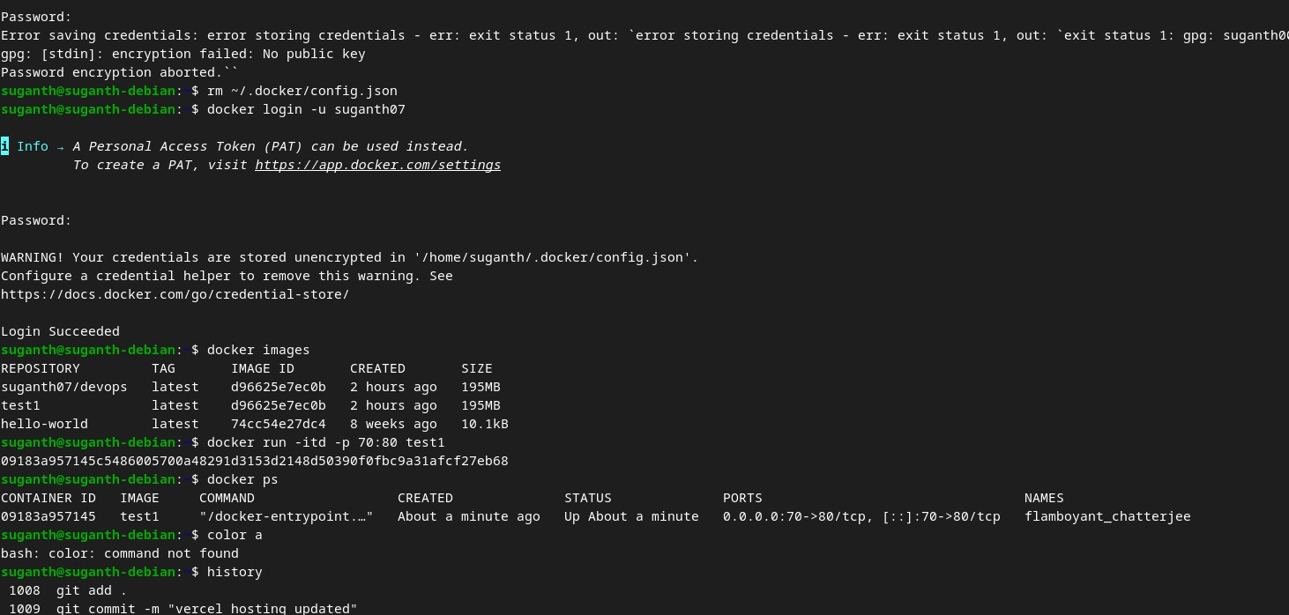

1. Go to the Browser and search for localhost:<PORT_NUMBER> and the respective application will be hosted.

**SCREENSHOT:**

